Argus Pharmacy-Network
PERFORMANCE TESTING STRATEGY

Prepared By: HT architects
Date: 2013/05
Version: 1.1
Revision History

Date | Version |  | Description | Author
2013/04/08 | 1.0 | First draft |  | Justin/Shmily, HT QA
2013/05/16 | 1.1 | Exclusive it for Pharmacy-Network system |  | Ruby

Introduction

Purpose
The purpose of this document is to outline the approach to ensure that the Performance Acceptance Criteria is met for Argus Pharmacy-Network Web applications. Specifically, this document details the:
- Performance Acceptance Criteria, performance test goals(objectives)
- Workload Characterization
- Production Environment and Test Environment
- Data preparation and data management
- Test Strategy
- Expected Results and Project Closeout

Scope
This document covers the Performance Acceptance Criteria; explains the user behavior models that will be executed; describes the testing theory and related metrics that will guide the tests; briefly discusses the resources required, including the toolset used to accomplish test execution; and the planed tests with results description in a narrative fashion.
This document is only intended to address performance testing strategy for Argus Pharmacy-Network system, although it is strongly recommended that this strategy be followed for all future releases.
This strategy doesn’t include functional testing, nor does it guarantee any specific performance results.
The primary objectives for this testing effort are to:
- Validate that the Performance Acceptance Criteria are met by the system.
- Identify and ensure that performance related defects are addressed prior to deployment.

Performance Acceptance Criteria

Introduction
Performance efforts always have two sets of criteria associated with them. The first is performance criteria (requirements and goals), and the second is engagement completion criteria. In the sections below, both types of criteria are explained for the Argus Pharmacy-Network system performance testing effort.

The performance effort will be deemed complete when either all of the performance criteria are met, or any one of the engagement completion criteria is met.

Performance Criteria
Performance criteria are the specific performance requirements and goals of the system under test.

The preferred result of the performance testing effort is to validate that the application meets all of these goals and requirements currently.

Performance Requirements
Requirements are those criteria that must be met for the application to “go live” and become a production system.

General Requirements
No general requirement is putted forward by the Argus team for the system under test.

Performance testing Goals
Goals are those criteria that are desired for the application which are in some way different than the previously stated requirements. Testing will continue until either all goals are met, or until time/money is at an end and the requirements are met.

General Goals
- Evaluate the response time of Argus Pharmacy-Network
- Evaluate the throughput of Argus Pharmacy-Network system.
- Evaluate the performance of Argus Pharmacy-Network system.

Specific Goals
No specific goal is developed for the test to Argus Pharmacy-Network system, so the performance testing effort is geared towards evaluating the performance of Argus Pharmacy-Network system.

Engagement Complete Criteria
In cases where performance requirements or goals cannot be achieved due to situations outside of the control of the performance testing team, the performance effort will be considered complete when any of the following conditions are met:
- All bottlenecks preventing the application from achieving the performance criteria are determined to be outside the team's control.
- The pre-determined engagement end date is reached.
- The PTG team and Argus Pharmacy-Network team agree that the application performs acceptably, although some performance requirements or goals have not been achieved.

Environment Description
This section describes production environment and testing environment for Argus Pharmacy-Network system. The testing environment is built on-site with different infrastructure to measure the performance of developed application by isolating the factor of network.

Development Environment
The Argus Pharmacy-Network system, deployed off-site, contains two server instances: Web Server and Database Server. Currently, the production environment is undefined. The development environment might be an important reference for building future production environment. Thus, evaluation in a test environment that be similar to development could partially predict the performance in both development environment and the potential production environment.

The detailed information of development environment is listed as below:
  - 20*CPUs(PowerPC_Power7), 3300 MHz CPU clock rate, 16GB memory
  - OS： AIX 7.1.1.16 TL00
  - Web sphere Application Server - ND, 7.0
  - DB2 version: 10.1

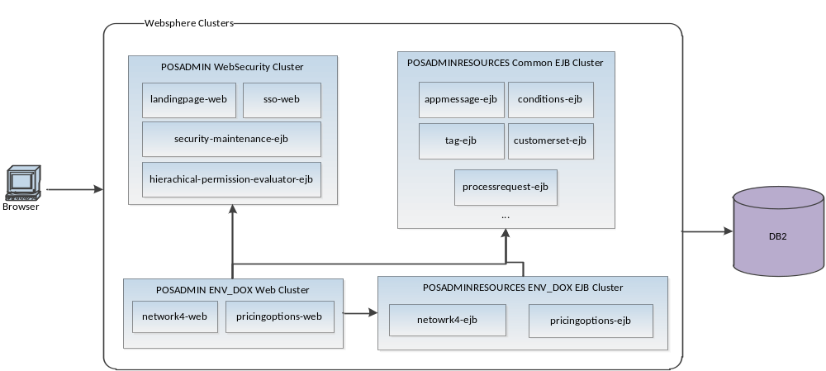

Figure 1 Logical view of Argus Pharmacy-Network Development Environment

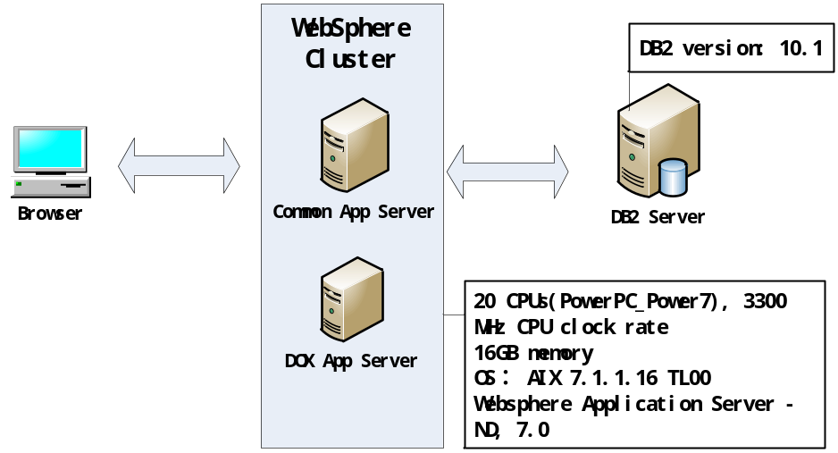

Figure 2 Physical view of Argus Pharmacy-Network Development Environment

Testing Environment
Argus has built a testing environment to host the Argus Pharmacy-Network application. This section focuses on the environment setup of the test environment. Figure 3 and Figure 4 shows the logical view and physical view of testing environment accordingly. The testing environment has some differences comparing with the development environment. Therefore, performance data gathered from this environment does NOT have the absolute relation with the true performance in development environment or production environment. However, these data can be used to predict the performance of the Argus Pharmacy-Network system.

The main differences between testing environment and development environment are:
1). Client, web server and DB server are deployed in Hengtiansoft’s internal network as testing environment instead of Argus internal network of production environment.
2). In the test environment, all web applications and EJBs are deployed on a single machine instead of on a cluster in production environment.

The detailed test environment information is listed as below:
a) Intel(R) Xeon(R) CPU E5645 2.40GHz, 16GB memory
b) Red Hat 4.1.2-48( linux 2.6.18-194.el5)
c) Websphere Application Server - ND, 7.0
d) DB2 version: 10.1

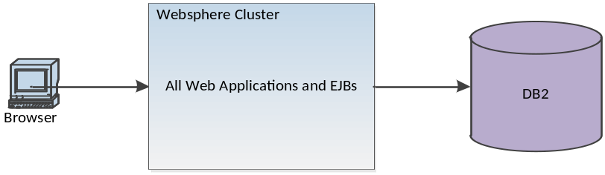

Figure 3 Logical view of Argus Pharmacy-Network Test Environment

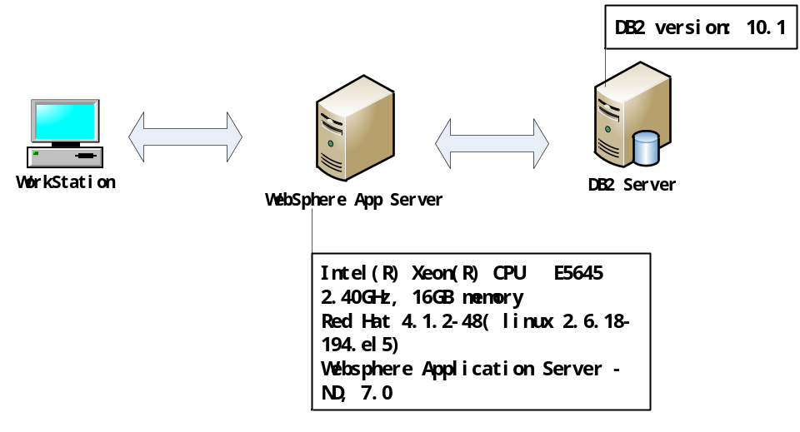
Figure 4 Physical view of Argus and Pharmacy-Network Test Environment

Goal-Based Performance Test Strategy

Pharmacy-Network System

Data Management
This section describes in detail the data management for the system to be tested. The data needed for a performance testing can be categorized into two types:
- Dynamic data we need to parameterize in tests.
- Data maintained by target system, generally including data in database or file server.
Dynamic data is described in specific goal’s workload characterization section.

Data Sources
Experiences show that the performance of a particular system might be largely affected by the volume of data in that system’s database. Thus, we should simulate the potential data environment of Argus Pharmacy-Network system based on planning, marketing and estimation.

In order to emulate data volume of Argus Pharmacy-Network system, PTG team can randomly generate data according to the Argus Pharmacy-Network DB design and insert into database. We will cover different volume of data to check different possibilities of the system performance. The detail volume will be determined in heuristic way during the test.

Table 22 – Network Rate Sheet Table

table_name |  |  | U80 |  | description
 | PK | FK | logical table name | physical table name | description | Size | NULL | FK | description
1 | O |  | RATESHEET_ID |  | DECIMAL | 3 | X
2 |  | O | CUSTOMER_SET_ID |  | DECIMAL | 5 | X
3 |  |  | RATESHEET_SHORT_NM |  | CHAR | 10 | X
4 |  |  | RATESHEET_LONG_NM |  | CHAR | 35 | X
5 |  |  | RATESHEET_STATUS_CD |  | CHAR | 1 | X
6 |  |  | RATESHEET_NOTE_TX |  | CHAR | 254
7 |  | O | COMPONENT_TYPE_ID |  | DECIMAL | 3 |  |  | Default value is 15

Table 23 – Effective Rate Sheet Table

table_name |  |  | U87 |  | description
 | PK | FK | logical table name | physical table name | description | Size | NULL | FK | description
1 | O |  | EFFECTIVE_RATESHEET_ID |  | DECIMAL | 7 | X
2 |  | O | RATESHEET_ID |  | DECIMAL | 7 | X
3 |  | O | COVERAGE_COMPONENT_ID |  | DECIMAL | 11
4 |  | O | CONDITION_ID |  | DECIMAL | 9
5 |  | O | CONDITION_SEQUENCE_ID |  | DECIMAL | 3
6 |  |  | CONDITION_MET_CD |  | CHAR | 1 | X
7 |  |  | EFFECTIVE_DT |  | DATE |  | X
8 |  |  | TERMINATION_DT |  | DATE
9 |  |  | MINIMUM_AT |  | DECIMAL | 9 | X
10 |  |  | MAXIMUM_AT |  | DECIMAL | 9 | X
11 |  |  | DISPENSING_FEE_AT |  | DECIMAL | 9 | X

Table1 and table2 are not too huge, the read frequency of these two tables would be higher than write frequency. The number of these two tables is about hundreds to thousands.

Table 24 –Rate Sheet Priority Table
table_name |  |  | U87 |  | description
 |  |  | RateSheet Priority |  | description
 | PK | FK | logical table name | physical table name | description | Size | NULL | FK | description
1 | O |  | RATESHEET_PRIORITY_ID |  | DECIMAL | 7 | X
2 |  | O | EFFECTIVE_RATESHEET_ID |  | DECIMAL | 7 | X
3 |  | O | CONDITION_ID |  | DECIMAL | 9
4 |  | O | CONDITION_SEQUENCE_ID |  | DECIMAL | 3
5 |  |  | CONDITION_MET_CD |  | CHAR | 1 | X |  | Default value is Z
6 |  |  | RATESHEET_PRIORITY_CT |  | DECIMAL | 5 | X |  | Default value is 1
7 |  |  | RATESHEET_PRIORITY_TYPE_CD |  | CHAR | 1 | X
8 |  | O | COVERAGE_COMPONENT_ID |  | DECIMAL | 11
9 |  |  | DISPENSING_FEE_AT |  | DECIMAL | 9 | X
10 |  |  | OVERALL_MAC_IGNORE_CD |  | CHAR | 1 | X
11 |  |  | MINIMUM_AT |  | DECIMAL | 9 | X
6 |  |  | MAXIMUM |  | DECIMAL | 9 | X

Table 25 – Rate Sheet Reimbursement Table
table_name |  |  | U81 |  | description
 |  |  | RateSheet Reimbursement |  | description
 | PK | FK | logical table name | physical table name | description | Size | NULL | FK | description
1 | O |  | RATESHEET_REIMBURSEMENT_ID |  | DECIMAL | 7 | X
2 |  | O | RATESHEET_PRIORITY_ID |  | DECIMAL | 7 | X | U89.priorityId
3 |  |  | PRICING_METHOD_TYPE_CD |  | CHAR | 1 | X
4 |  |  | PERCENTAGE_ADJUSTMENT_RT |  | DECIMAL | 10 | X
5 |  |  | FLAT_PRICE_AT |  | DECIMAL | 9 | X
6 |  |  | FLAT_PRICE_LIST_ID |  | DECIMAL | 9
7 |  |  | DISPENSING_FEE_AT |  | DECIMAL | 9 | X
8 |  |  | VACCINE_ADMIN_FEE_AT |  | DECIMAL | 9 | X
9 |  | O | VENDOR_BENCHMARK_ID |  | DECIMAL | 5
10 |  |  | CMPR_LSR_MAC_PRCG_MTHD_CD |  | CHAR | 1 | X
11 |  |  | INHRT_NTWRK_RS_DSPNS__FEE_CD |  | CHAR | 1 | X
12 |  |  | RATESHEET_PRIORITY_CT |  | DECIMAL | 5 | X

Table3 and table4 are larger than table1 and table2, the number of these two tables is about ten thousands, and these two tables have high write frequency.

Goal 1: Response time evaluation

Introduction
Response time is an important indicator of a web application. Argus Pharmacy-Network system is B/S based medical pricing management system. One performance test goal of Argus Pharmacy-Network system is:
- Evaluate the average response time over different load depending on the importance of scenario. There are three level access frequencies: high level, medium level and low level. High level has 70% access probability with 50 peak number of user connection; medium level has 20% access probability with 20 peak number of user connection; low level has 10% access probability with 10 peak number of user connection.
- The minimal test times for each page used for calculating the average response time should be larger than 20.

Strategy

4.1.2.2.1 Theory
Response time of a request is the interval between user sending an http request to a server and the server send back the http response to user. This process includes domain name resolution, establishing http connection and data transmission. Figure 5 briefly describes the process of an http request. The calculation of response time can be approximately denoted as following:

Response time of a request=T1+T2+T3+T4

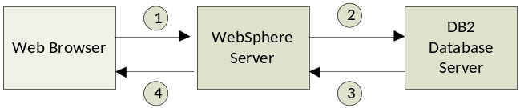
Figure 8 Response time of request

Response time of a web page is the interval between the sending out the first http request and the finishing of receiving the last http request.
The following metrics might be used to roundly display the response time:
- Arithmetic mean ， mean or average
The mean is the arithmetic average of a set of values.
- Percentiles
A percentile is the value of a variable which a certain percent of observations fall, this index will be used like “the 95% of response time is less than 100ms”
- Medians
The number which is located in the middle of a set of values
- Normal Values
The value appears most frequent in a set of values
- Standard Deviation
Shows how much variation or "dispersion" exists from the average, it used to measure the stability of the given data set

Theoretically, we can get the response time sequence and calculate the statistics listed above to analyze the testing result from different perspectives.
Additional metrics should be collected from server in order to help identify the load level, system bottleneck, system status and running of tests:
- CPU usage
- RAM usage
- SWAP usage
- IO Speed
- Network Speed
Statistics, such as average, percentiles, medians, normal values, and standard deviation, can be used to show different aspects of system dynamics.

4.1.2.2.2 Workload Characterization
The following sections describe the workload characterization to be used for evaluating the performance of Argus Pharmacy-Network system. The workload is estimated by the Argus team, we can’t get the real distribution information by analyze the runtime log of the system for the Argus’ business specific requirement still under development.

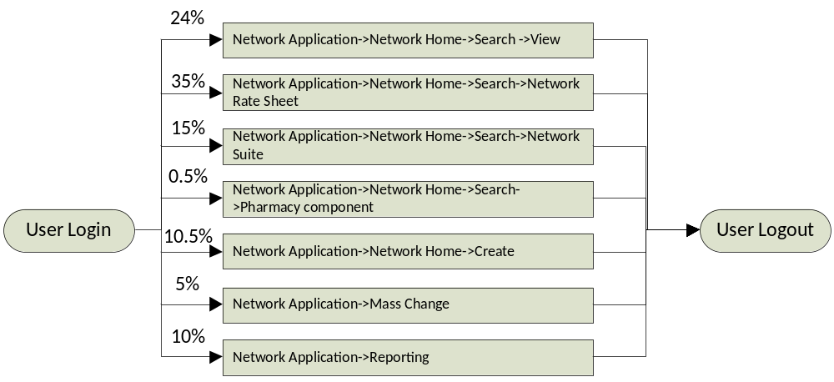

Figure 9 Argus Pharmacy-Network workload

According to Argus team, there are seven main business scenarios in the system:

- Network Application->Network Home->Search ->View
- Network Application->Network Home->Search->Network Rate Sheet
- Network Application->Network Home->Search->Network Suite
- Network Application->Network Home->Search->Pharmacy component
- Network Application->Network Home->Create
- Network Application->Mass Change
- Network Application->Reporting

4.1.2.2.3 Solution
This section describes the proposed methods to performance test the Argus Pharmacy-Network system.
Given the workload distribution and workflow, we transform all possible paths into sequential processes. Each process will be associated with a probability. The concurrent virtual user number of a process will be: VUs * P,
Where VUs represents the total number of virtual users simulating a process, P denotes the probability of a specific process.
The system will be tested over different VUs to draw out the trend of response time (both requests and web pages) with the increase of concurrent users.

4.1.2.2.4 Test cases
In this section, we detail all the test cases for Pharmacy-Network sub-system. Considering the space of the document, we include the parameterization tables separately in other documents archive. The parameterization tables can refer to “Pharmacy-Network Workflow Parameterization Table.zip”, we kindly remind you to have a look at the readme file first when you looking into those data.
The following tables contain all the sequential workflow we will execute in the performance tests.

Table 26: Test cases for search procedures with Master customer set
Sub workflow: Network Application->Network Home->Search
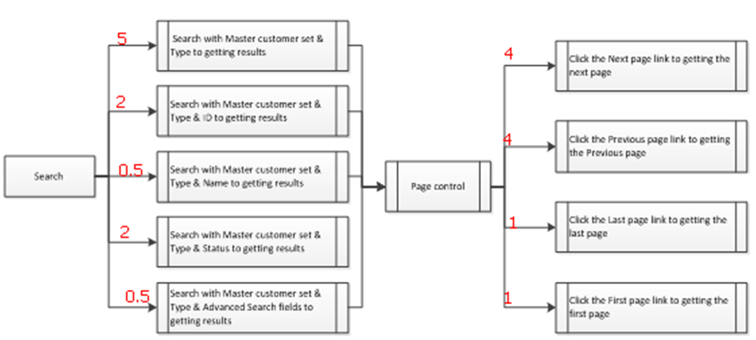
Table 27: Test cases for search with Network Rate sheet
Sub workflow: Network Application->Network Home->Search->Network Rate Sheet
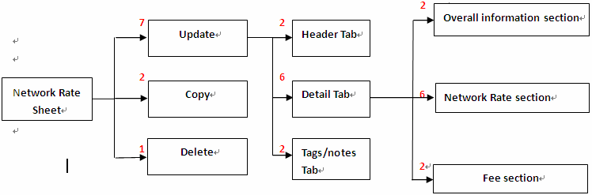
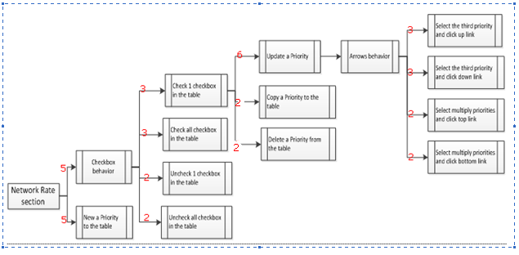
Table 28: Test cases for search procedures with network suite
Sub workflow: Network Application->Network Home->Search->Network Suite
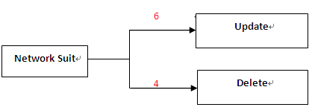
Table 29: Test cases for search procedures with pharmacy component
Sub workflow: Network Application->Network Home->Search->Pharmacy component
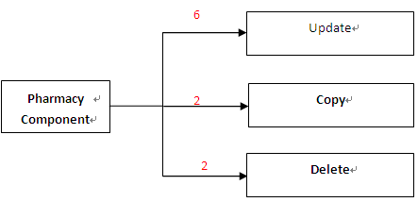
Table 30: Test cases for Network Home with create
Sub workflow: Network Application->Network Home->Create
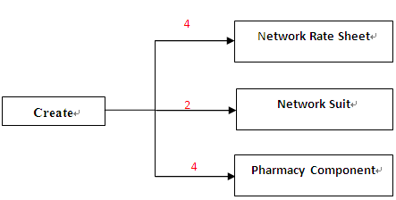
Table 31: Test cases for network application with mass change
Sub workflow: Network Application->Mass Change
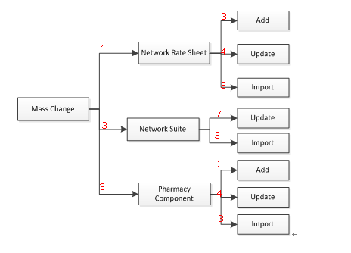
Table 32: Test cases for network application with reporting

Sub workflow: Network Application->Reporting
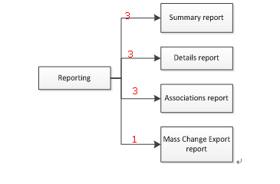

Goal 2: Throughput evaluation

Introduction
System throughput is the sum of workload unit that are processed by server within a unit time. It is an importance indicator of system efficiency. Many factors may influence system throughput, such as workload, software architecture, hardware and system configurations.

Strategy

4.1.3.2.1 Theory
Throughput refers to the yield or the amount of service which business system provides within a unit time. Throughput is usually the overall evaluation of the capacity of a system and its components processing transmission data request's ability. Throughput of web application system is usually measured in requests per second or pages per second.
Theoretically, we can get the request sequence and calculate the windowed throughput over time series.
Additional metrics should be collected from server in order to help identify the load level, system bottleneck, system status and running of tests:
- CPU usage
- RAM usage
- SWAP usage
- IO Speed
- Network Speed

These metrics are usually processed with the same time window applied for throughput calculation. All these data can be combined to analyze the performance of system.

4.1.3.2.2 Workload Characterization
Because the throughput will be also evaluated when testing the response time, thus the workload characterization is the same to section 4.2.2.2.2.

4.1.3.2.3 Solution
This section describes the proposed methods to measure the throughput of Argus Pharmacy-Network system.
Given the workload distribution and workflow, we transform all possible paths into sequential processes. Each process will be associated with a probability. The concurrent virtual user number of a process will be: VUs * P,
Where VUs represents the total number of virtual users simulating a process, P denotes the probability of a specific process.
We will measure the system throughput over different load levels to predict the process ability of system.

4.1.3.2.4 Test cases
Because the throughput of Pharmacy-Network sub-system will be also evaluated when testing the response time, thus the Test cases are the same to section 4.2.2.2.4.

Project Closeout

Closeout
The Project Closeout aspect here has two activities, but these activities are important and independent enough to deserve an aspect of their own. The activities are:
- Document Results
- Common Code Review and Clean Up

Typically, the Results document includes:
- Statistics (Graphed) and explanations grouped by user load and scenario
- Notations where actual responses did not achieve stated goals
- Analysis of reported times, in particular where times did not meet stated goals
- Appendices including:
  - Spreadsheets of recorded times (min, max, average, and std) for each user load
  - Spreadsheet of average times grouped by user load
  - Test execution reports (copied directly from PeTS) for each test executed

Common code review and clean up includes:
- Review the common code and bug fix
- Rewrite some utility scripts using testing framework preferred programming languages
- Design and implement common code with regard to new requirements met in project process

Results Description
This section briefly describes the results of the performance testing effort for Argus Pharmacy-Network system.
The main delivery of the performance testing is a report of performance testing result. The report will at least include the following aspects:
1) Configuration:
The configuration summarizes the runtime parameters for the test such as session configuration, data configuration and user configuration;
2) Result:
The results part mainly includes some charts that describe the delivery time/throughput curve against the increase of concurrent virtual users or gateways.
3) Analysis and Tuning:
This part includes which component is not meet the stated goals, and why. After the problem is determined, tuning strategy will be introduced. This part also contains comparison of performance before and after the tuning.

Result statics description
There are three main indicators that will be measured that are Number of user connections, Number of concurrent request, Delivery time(two directions) and throughput, assistant metrics of hardware will also be measured.
- Number of user connections: In practical, user may logon to the system but not do any operation. But, even no operation comes from a user, maintains user’s connect still costs hardware resources, this metric is used to measure the number of user connections.
- Number of concurrent request: this is one of the most metric that can measure the performance of the Argus Pharmacy-Network system.
- Delivery time (two directions): the time from sending web request to the gateway received the command, or the gateway sends message till the database been updated.

CPU utilization, RAM and SWAP utilization, I/O speed, network speed. All the hardware related statistics can be used to measure the pressure of the Argus Pharmacy-Network system coursed to the physics machine. If the hardware utilization is over the threshold which is defined by the system administrator, the system can be considered to be unstable.

Below are the charts and table generated by default Jmeter-plugins. The sample test used here is a web based projects that makes table and charts contains information about HTTP request. But in the case of Argus Pharmacy-Network system, we will use the same analysis tool to do generate similar tables and charts, but the context will be slightly different: it is no longer HTTP request but message flow for Argus Pharmacy-Network system.
In the case of Argus Pharmacy-Network system, the report will contains more information just as we listed above.
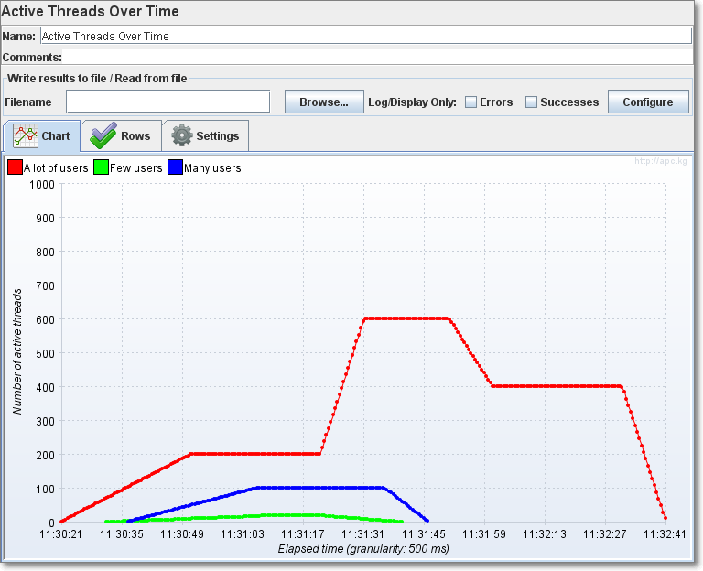
Figure 6 Active Threads Over Time Listener
Active Threads Over Time is a simple listener showing how many active threads are there in each thread group during test run.

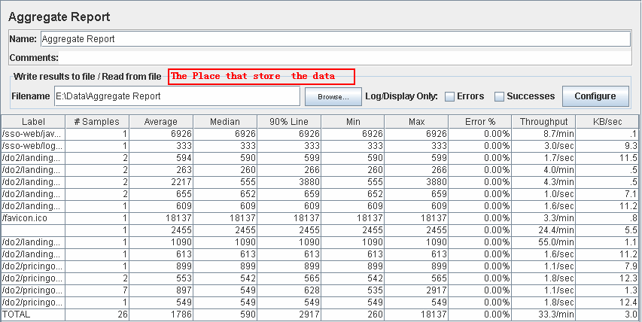
Figure 7 request report
The Aggregate summary provides a report for every request; all the columns can be sorted.
- Label - The label of the sample. If "Include group name in label?" is selected, then the name of the thread group is added as a prefix. This allows identical labels from different thread groups to be collated separately if required.
- # Samples - The number of samples with the same label
- Average - The average time of a set of results
- Median - The median is the time in the middle of a set of results. 50% of the samples took no more than this time; the remainder took at least as long.
- 90% Line - 90% of the samples took no more than this time. The remaining samples at least as long as this. (90 th percentile )
- Min - The shortest time for the samples with the same label
- Max - The longest time for the samples with the same label
- Error % - Percent of requests with errors
- Throughput - calculated as requests/unit of time. The time is calculated from the start of the first sample to the end of the last sample. This includes any intervals between samples, as it is supposed to represent the load on the server. The formula is: Throughput = (number of requests) / (total time).
- Kb/sec - The throughput measured in Kilobytes per second)
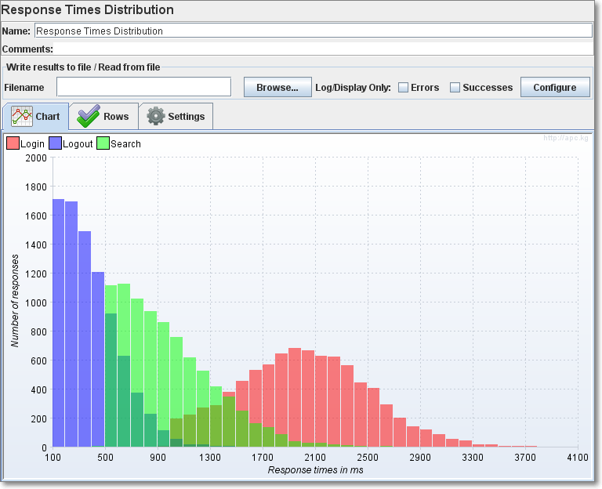
Figure 8 Response Times Distribution
This graph will display the response time distribution of the test. The X axis shows the response times grouped by interval, and the Y axis the number of samples which are contained in each interval.
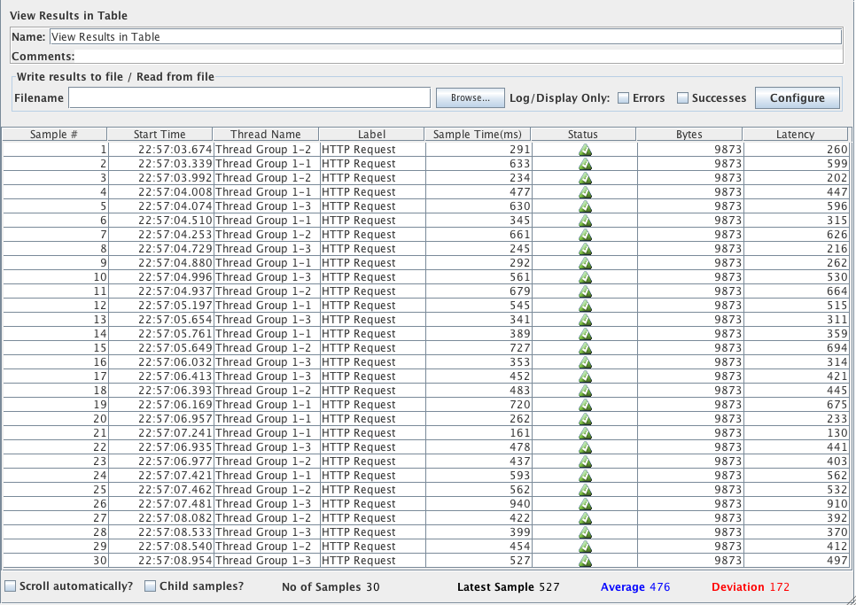
Figure 9 View Results table
This graph will display the Sample time and status of the test. It can help you to find out which request cause the problem when you locate the test case.

